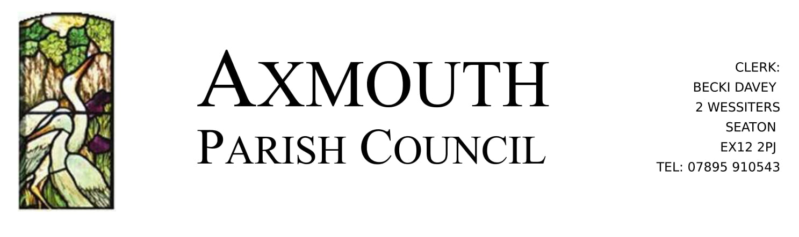
9th June 2021

To all Parish Councillors,

Councillors are summoned and members of the public are invited to attend the Council Meeting (Planning) of Axmouth Parish Council, to be held at Coronation Corner on Wednesday 16th June at 7:00pm to discuss the following matters

RDavey

Becki Davey
Clerk to the Council

Agenda

To receive and acknowledge apologies.

- Declaration of Interests: In accordance with the Code of Conduct, members are invited to declare any personal or disclosable pecuniary interests, including the nature and extent of such interests they may have, in items to be considered at this meeting. Members are also reminded that any change to their Declaration of Interests must be notified to the Monitoring Officer at East Devon District Council within 28 days of the change.

- Planning Applications:
21/1435/FUL - Cringleford Cottage Stepps Lane Axmouth Seaton - Erection of a replacement dwelling with associated amenity space and erection of a detached single storey double garage
21/1435/FUL | Erection of a replacement dwelling with associated amenity space and erection of a detached single storey double garage. | Cringleford Cottage Stepps Lane Axmouth Seaton EX12 4AS (eastdevon.gov.uk)
21/1440/FUL - 38 Church Street Axmouth Seaton EX12 4AF - Replacement detached double garage including ancillary habitable space, and installation of driveway
21/1440/FUL | Replacement detached double garage including ancillary habitable space, and installation of driveway. | 38 Church Street Axmouth Seaton EX12 4AF (eastdevon.gov.uk)

As this meeting is outside, please be prepared for the weather, and study the relevant documents (links above) prior to the meeting.

Date of the next Parish Council Meeting: 21st July 2021

