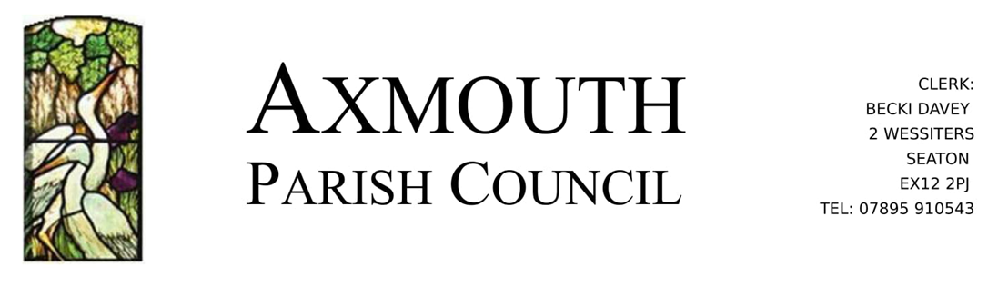

Annual Parish Meeting

Notice is hereby given that the
Annual Parish Meeting of Axmouth
will be held in Axmouth Village Hall
on Wednesday 20th April at 7.00pm

The Annual Parish Meeting is an opportunity for parishioners on the Electoral Roll for Axmouth to raise any matters of concern to them that relates to their local community.

It would be helpful to have written notice of any matters to be raised but it is not essential. Matters can be raised at the meeting without prior notice.

For any queries, please contact the Clerk to the Parish Council.

